\ | 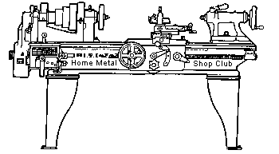  Volume 10, No 1 - January 2005

President - | Chuck West | Vice President - | Doug Chartier
Treasurer - | John Hoff | Secretary - | Steven Clay
Webmaster  -  Librarian - | Dick Kostelnicek  Doug Chartier  Dennis Cranston | Editors - | Jan Rowland  Dick Kostelnicek
Founder - | John Korman | SIG Coordinators - | Dennis Cranston  Richard Pichler
Statement of Purpose
Membership is open to all those interested in machining metal and tinkering with machines. The club provides a forum for the exchanging of ideas and information. This includes, to a large degree, education in the art of machine tools and practices. Our web site endeavors to bring into the public domain written information that the hobbyist can understand and use. This makes an organization such as this even more important.

December Regular Meeting
Collier Library, Houston Texas, December 11, 2004, 1:00 p.m., Chuck West - President, presiding. There were 30 members attending with four guests: Dan Harper, Jim Clark, Tim Bailey, Rob Lucas-Dean.

Business Meeting
Minutes are sent via email or regular mail to club members.

Presentation
Joe Scott showed and discussed some videos. The first video dealt with forging of the M1 machine gun receiver. The second covered various aspects of manufacturing the Johnson Rifle.
Special Interest Groups Activity:
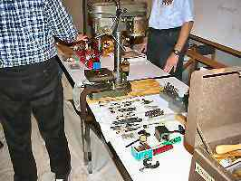
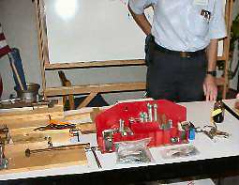
Novice Sig
The novice group discussed types of drills bits and hole drilling. They aligned (trammed) the drill press using a dial indicator in order to determine the perpendicularity of the table to the spindle's axis. Then they checked the runout of the chuck. Examples of excessive speed (RPM ) were shown along with correct speed vs. drill diameter vs. metal type were demonstrated. The need for center punching and use of pilot holes was explained. Various drill fixtures and jigs were shown. The group had hands-on practice feeding drills for optimum drill life using a Teflon block and measured the drill chip thickness with a micrometer.
Machinist's notebooks were distributed to the two new novices.
The January meeting will be about sharpening shop tools. Please bring a tool (knife, chisel, screw driver, high speed. lathe tool bit, etc.) that needs sharpening. We will also try to demonstrate a layout procedure using the 6-in. dial caliper with the aid of a video camera and the large TV screen.
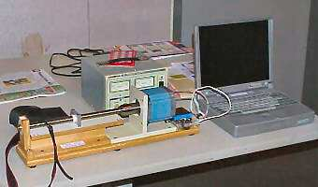
CNC Sig
Jan Rowland brought in a show-and-tell setup of a lead-screw turned by a stepper-motor driven by a famous Gecko drive directly connected to the printer port of a laptop. With that, it could be demonstrated how programmed moves could be easily made with home-brew hardware.

Show and Tell
Doug Chartier showed a very nice tapping head for his machining center.
Joe Scott showed a tail stock turret and some tap and die holders for it.
Tim Bailey showed a rather impressive hand forged curtain rod end.
Rich Pilcher showed a shop built tail stock live chuck and list of operations for making the adapter and a micrometer stop chamfer tool.
Jan Rowland discussed a density calculation to try to determine the makeup of an unknown material. He also showed a photo of last months knife display.
Joe Scott talked about die drills and tapping a case hardened rifle receiver.
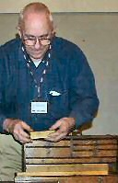  Joe Williams passed around his C-clamp that was pictured and discussed in last months news letter. He also showed an old toolbox and it's contents that he recently acquired. | 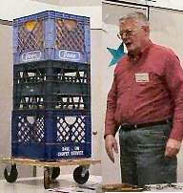  Tom Moore showed his milk crate dolly he uses for storage. | 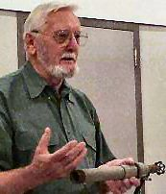  Rob Lucas-Dean showed his shop made Propane Burner and asked about furnace building. | 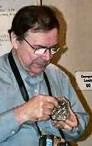  Dick Kostelnicek showed a commercial shim punch.
Featured Articles

Measuring Density on the Cheap
by Dick Kostelnicek and Jan Rowland - HMSC Members
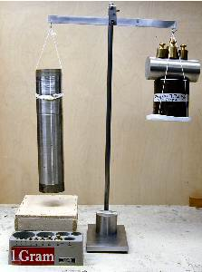
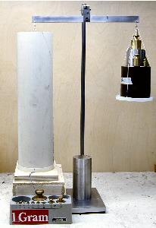
If you have a piece of material, it could be a metal or wood bar, and you want to determine its specific density, that is the density relative to water, in order to identify its composition, then read on.. Now, normally you would first have to determine the volume of the bar. However, measuring volume is often a messy job since you need to submerge the piece under water and note the amount of water displaced. This can be done with a graduated cylinder or an overflow tank.

Well, you can get the specific density directly with just a bucket of water, a length of string, and a fish weighing scale. Now, the water in the bucket should be deep enough so that the unknown bar of material will be completely submerged without touching the bottom of the container. It is OK if the bar wants to float so long as the bucket is big enough that the bar can be submerged completely under water with the help of an addition sinker weight.
Method for density greater than 1.0: ( This is where the bar sinks on its own )
Weigh the bar hanging from a string in air. Call this amount Wa.
Weigh the bar hanging from the string and completely submerged under water but not touching the bucket's bottom. Call this amount Wb.
Then, the specific density D is given by the formula: D = Wa / (Wa - Wb).
Method for density less than 1.0: ( This is where the bar wants to float )
Get a sinker weight that is just heavy enough to submerge both the unknown bar and the sinker when both are lashed together.
Weigh the bar alone in air. Call this amount Wa.
Determine the weight of the sinker by itself under water. Call this amount Ws.
Finally, lash the bar and the sinker together and weigh them with both completely submerged. Call that amount Wt.
Then, the specific density D of the unknown bar is given by the formula: D = Wa / (Wa + Ws - Wt)
Now, often you'll find that you don't have an accurate or sensitive fish scale at hand, but you do have a good platform scale. On the platform scale place a weight that is heaver than the unknown bar in air. Tie the free end of the string that is attached to the unknown bar around the platform weight after passing it over an overhead pulley. Weigh the platform weight with and without the string attached to the unknown bar. The difference of these two measurements is the weight of the suspended bar alone. You might want to use two pulleys at the same height so that the vertical string attached to the bar does not interfere with that attached to the platform weight. Both vertical portions of both ends of the string must be truly plumb to ensure an accurate measurement.
Jan Rowland - HMSC Member supplied the photos and constructed a beam balance using an ultra low friction precision ball bearing for his density measurements .
More on Shop Air Shut Off
by George Carlson - Former HMSC Member
I saw your article on using a photocell to control the compressed air in your shop. I have my compressor mounted outside in a little lean-to. It's nice, because it doesn't take up space in the shop, and the insulation in the lean-to cuts the noise to a whisper. Once, the compressor threw a belt, and the motor ran for two days. So I had to come up with a fix. I wired a contactor (electrical relay) in series with the 240VAC to the compressor. The primary or control side of the contactor is connected to the shop's 110VAC lighting circuit. So, now the compressor can only run when the shop lights are on.... a very simple fix that works quite well.

Manual Lever Feed for a Mill-Drill
by Joseph Scott - HMSC Member
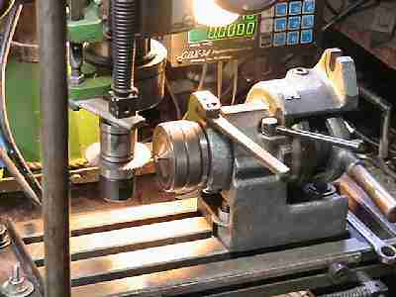
I needed to slot about 100 small fillister head screws on my mill-drill. Cranking the Y-axis got old and was hurting my wrist, so I made a modification to mill. Basically, I removed the Y-axis feed screw and installed a wobble stick hand-lever to move the table for the slotting operation. Later, I took out the X-axis screw so that the single lever would move the table in any horizontal path like a joy stick. I will use it in the future to trace 2-D patterns form original gun parts.
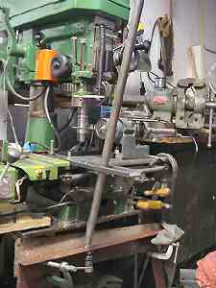

I did it this way: Drilled 2x1/2-in. channel to clamp on table with an additional hole for a 3/4-in. pipe lever. Clamped a 2x2-in. angle onto the mill's support legs and put a 1/2-in. bolt sticking up to form a pivot point. Removed the Y-axis screw and loosen its gib. Cleaned and oiled slide. Positioned table for depth of screw slot and locked the X-axis slide.
The screw slotting operation is as follows: Lever the table outwards. Install a new screw in the collet. Lever the table backwards for the cut. Reverse the lever. Repeat the operation.
Long ago I think these lever operated machines were called profilers.

The next meeting will be held on Saturday January 8, 2005 at the Collier Library 6200 Pinemont, Houston, TX at 1:00 p.m. Bring along a work in progress to show.  Visit Our Home Page at  homemetalshopclub.org | 