 | 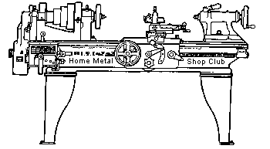  Volume 9, No 3- March, 2004

President - | Tom Moore | Vice President - | Chuck West
Treasurer - | John Hoff | Secretary -
Webmaster -  Librarian - | Dick Kostelnicek  Dennis Cranston | Editors - | Jan Rowland  Dick Kostelnicek
Founder - | John Korman | SIG Coordinators - | Dennis Cranston  Richard Pichler
Statement of Purpose
Membership is open to all those interested in machining metal and tinkering with machines. The club provides a forum for the exchanging of ideas and information. This includes, to a large degree, education in the art of machine tools and practices. Our web site endeavors to bring into the public domain written information that the hobbyist can understand and use. This makes an organization such as this even more important.

Regular Meeting


Collier Library, Houston Texas, 1:00 p.m., February 14, 2004, Tom Moore, President, presiding. 29 members were present, including one visitor Dan Vernon.
Steve Hall brought his set of tools to sell as he can no longer use them in his trade.
The club secretary resigned. All those applying for the job, contact the president at the next meeting.
Business Meeting
Minutes are sent via email or regular mail to club members.
Presentation

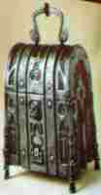
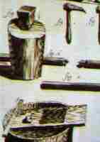
Vance Burns, the club's only admitted blacksmith, gave a slide presentation on the history and avocational art of blacksmithing. Vance assured us that he is not a "farrier", one who shoes horses, but a blacksmith. For he creates articles in iron by the application of the hot forging, bending of iron. He explained the various parts of anvil as: the horn, or beak - the tapered end used to form shapes of various radii, the round pritchel hole - for punching holes, the heel - flat area used in striking and expanding metal, and the square hardy hole - for holding hardy tools used in swaging, bending, and cutting . He showed a variety of wrought articles made by his fellow blacksmiths.
Show and Tell
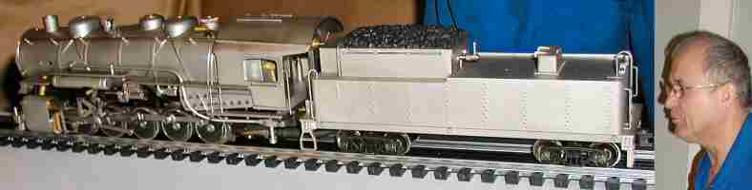
Charlies Mynhier ran his 0-10-0 model switcher engine on a internal propane fired steam boiler over a short length of track.
  Gordon Lawson showed photos of the Challenger steam engine's recent visit to Houston TX. See article below. | 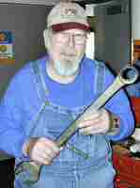  Doug Chartier showed some wrenches that he uses to tighten some big collets. |   Dick Kostelnicek showed a miniature nut driver that he uses for model hex head screws. See article below. |   Tom Moore showed his large gas mixer for a gas fired crucible furnace.
Special Interest Groups Activity
Novice Sig
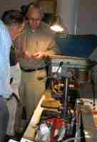

Jan Rowland demonstrated the Precision Fastening and Dowelling Tricks that was written up last month's newsletter and answered questions from the novice group. Joe Williams demonstrated his diamond wheel tool grinder that sharpens carbide tools. The drilling demo was repeated, which included several methods for locating the center of round stock in preparation for center drilling.
Next month, we will have a sharpening workshop. Club members, in addition to novices, are invited to bring tools that need sharpening. Sharpening topics include: high speed tool bits, off-hand drill sharpening, cam machine drill sharpening , pocket knife, wood chisel, axe blade, screw driver, and masonry drills. by Rich Pichler
Comments on last month's articles
We have received some comments on Jan Rowland's article Precision Fastening and Dowelling Tricks
Jan could have mentioned using the top section as a tap guide. Another technique is to use a tubular dowel with the bolt thru the hole and a washer on the outside. by Joe Williams.
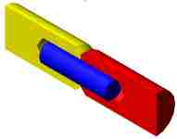
One thing the author of the dowel pinning article left out was, when welding up an assembly that was dowel pinned together, it is very important to get everything absolutely clean. A while ago I had a drive shaft that I wanted to extend a few inches. I decided that I would use a lathe to drill and ream a hole in both the extension and the shaft and use a dowel pin to align the two shafts. I pressed the assembly together and started to weld. Shortly after I had struck an arc there was a huge explosion. It sounded like a rifle shot. In my haste, I did not degrease the pieces as well as I should have and a minute amount of cutting oil was still in the bottoms of the holes. The oil boiled and when the pressure got great enough, the assembly blew apart. The shaft about (4-lbs.) sailed to my right about 50-ft. I never recovered the shaft extension. Since then I have always put a vent hole in the bottom of such and assembly, or if that is not possible I get it very, very clean and make sure that if it was to go "kaboom", it would not hit me. by William Dodge
Mill/Drill and Drill Press Alignment during Tool Changes
by Ed Gladkowski - HMSC Member
When performing multiple operations on the same work piece, while using a drill press or mill/drill with a round column instead of a dovetailed column, a problem arises when changing from short to long tooling, especially if the machine has limited quill travel. If the machine spindle has to be brought close to the work for, say, a center drill, there is often insufficient room to change to a long drill or reamer without swinging, or raising the machine head, or swinging or lowering the drill press table. There have been some elaborate “fixes” to retain alignment in this situation, especially for mill/drills, for example, milling keyways the whole length of the round column with keys in the machine head to match; or mounting a laser pointer on the head targeted on a vertical line marked on the shop wall.
A quick and simple method I’ve had good luck with is as follows:
(1) If the head (or table) of the machine only has to be swung sideways to change a tool, mount a magnetic-base indicator on the work, vise or table with the indicator point zeroed against any solid point on the head. Unclamp the head or table, swing it far enough to change the tool, then swing it back and re-clamp it at the original zero indicator reading.
(2) If the machine head has to be raised (or the table lowered), attach the indicator to the machine's head magnetically or in the chuck or collet. Clamp a parallel vertically to the work, or to an angle plate or in a vise on the table. The parallel needs to be a little taller than the amount you need to raise or lower the machine’s head or table. Zero the indicator against the edge of the parallel, unclamp the head or table, and move it up or down. Then, re-clamp it at the same zero indicator reading, at its new position along the length of the parallel.
Challenger Visit to Houston, TX
by Gordon Lawson - HMSC Member
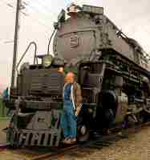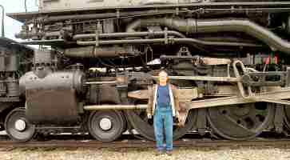
The Union Pacific Challenger, No. 3985 was recently in town for Super Bowl activities. It was located at the intersection of Holly Hall and Almeda streets in Houston TX..
Union Pacific built 105 Challenger steam engines between 1936 and 1943. No. 3985, the one in accompanying photos, was built in July, 1943, by the American Locomotive Company (ALCO) at their Schenectady Works plant. It is the largest operating steam locomotive in the world today. On its way to and from events, like the Super Bowl, it hauls freight, so it does "pay it's way". The 3985 last operated in regular train service in 1957. It was officially retired in 1962 and was stored in Cheyenne, Wyoming, and was placed on display in 1975 near the Cheyenne depot. A group of Union Pacific employee volunteers restored the locomotive to running condition in 1981. It was converted to run on fuel oil in 1990.
The specifications:
Wheel arrangement: 4-6-6-4
Weight: 1,070,000 pounds
Height: About 17 feet.
Length: About 122 feet.
Steam pressure: 4 X 21-in cylinders @ 280 psig to power twelve 69-in dia. driving wheels developing 97,350 pounds of tractive force
Firebox: 132 square ft.
Articulation: The frame of the locomotive is hinged ahead of the rear cylinders which allows the engine to follow curves easily.
Tender: The tender is called a "caterpillar", based on its appearance. It has 14 wheels. It holds 25,000 gallons of water and 5945 gallons of No. 5 fuel oil. Originally, it had a tender that carried 32-tons of coal.
Top speed: 70 Miles per hour.
Controlling hole depth when using the lathe tailstock
by John Hoff - HMSC Member
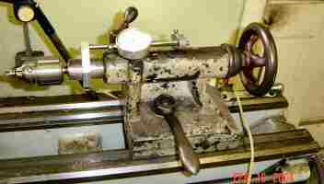
I needed to drill a blind hole in a number of pieces to a precise depth of 0.200-in. Counting the number of turns or fraction of turns on the lathe tailstock wheel just wouldn’t be accurate enough. To solve my problem, I’ve mounted a 1-in. travel dial on my lathe tailstock.
The travel dial is mounted with the measuring pin facing in the direction of the tailstock wheel. A clamp is attached to the tailstock spindle capable of holding a rod rigid extending above the tailstock casting and back toward the tailstock's wheel. A metal arm with a thumb screw adjustment slips over the rod and contacts the travel dial shaft.
Now, whenever I need precise drilling, I advance the drill point until it just touches the work, move the arm along the rod until it contacts the travel dial, tighten the thumb screw, set the dial to zero and drill away.
Work Support - Milling Machine
by J. R. Williams - HMSC Member
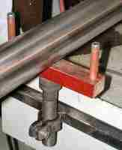
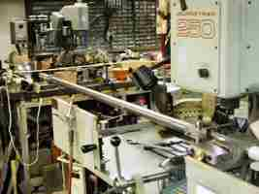
The left hand photo shows a work support that I fabricated to support long work held in my milling machine's vise. This job was to mill a short slot in the end of an 8 ft. section of 1-1/2-in. stainless steel pipe. There was no problem holding the work in the vise but the length of the work made it almost impossible to support the work and keep it level and close the vise. I have stacked up parallels and used wedges in the past but that was not satisfactory. The support is built around a 3/4-in. socket head cap screw with a hole drilled and tapped in the end for a 5/16-in. flat head screw to hold the linen filled phenolic material on the end of the large screw. The ends have 1/4-in. socket head cap screws with copper tube sleeves. The phenolic material and copper tube sleeves were used to prevent any marking of the work. The large nut has two tabs welded on to provide the clamp action after the nut was split with a saw. The nut is welded to a section of 3/4-in. square tube material that is bolted to the outside of the mill's splash shield. The position allows the slide-in shield section to be replaced and does not interfere with the table slots.
In the right photo, notice the use of my work stop unit that is over the tube near the vise to prevent the work tube dropping down when the vise is loose. Having the support at the correct height has been a big help. The height was set by using a long straight edge clamped in the vise and the work support adjusted up to touch the straight edge's blade. As you can see, space is a premium in my shop, especially with long work. To assemble a welding torch, that uses the 8-ft. SS tube, I have to slide parts together coming into the shop thru the outside door.
Cutting Oil Cup
by J. R. Williams - HMSC Member

A necessity in the shop is a small cup holding cutting oil and a brush. I have used many different containers and today, as I was cleaning up the shop, an empty disposable propane cylinder was about to be tossed when I decided the bottom three inches of the cylinder would make a good cutting oil container. Furthermore, it had a good flat base. A quick pass thru the cut-off bandsaw, with coolant on, resulted in the container. (Caution - be sure the cylinder is empty). A plastic top rim section ( 1/2" thick) was turned from a section of High Density Polyethelene and pressed in to the top of the cut off section. The slightly extended rim makes it easy to handle.

Make Your Own Hex Drivers
by Dick Kostelnicek - HMSC Member
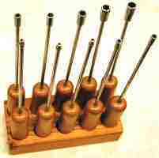
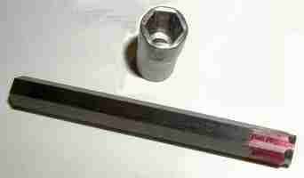
Recently I made a set of hex nut-&-bolt drivers, sometimes called "spintights", for model hex head screws. These screws mimic to scale large full size bolts and are generally taller in head height than conventional miniature hex head screws. Furthermore, the hex sizes (distance across the flats) are sometimes not available in common spintights. Also, commercially made spintights have a thick socket wall and short-thick shank, making them all but useless in getting into tight places on engineering models. I made a set of ten drivers ranging from #0-80 (3/32-in across flat) to #12-24 (5/16 across flat). Each has a 1-ft long 3/16-in. diameter driver shank. The socket wall thickness is a mere 0.045-in. The wood handles are made from a discarded broom handle.
Construction of the hex socket begins by cutting off and discarding the short arm of a hex Allen key wrench of the desired size in order to make an internal hex anvil. I one case, there was no standard key wrench available with the desired across flat size, Here, I used a larger wrench and ground down all six sides on a surface grinder. The hex anvil is 45-deg. chamfered at one end down to the across flat diameter. It is then driven into a blind hole in the socket of the anvil's diameter with either a hammer or arbor press. This forms an imperfect internal hex cavity in the socket blank. At this point it is nearly impossible to remove the hex anvil from the socket.
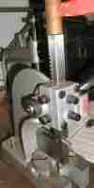
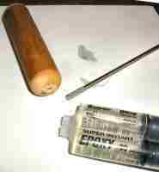
The socket with inserted anvil is then struck on all six sides near the socket's open end with a hammer in order to cold forge the socket around the anvil. This process also loosens the anvil in the socket's hex cavity, thereby giving sufficient socket clearance for the required hex size. Rather than use a hammer, with the possibility of hitting a finger, I employed a small arbor press and steel block to compress the socket against the flats of the hex anvil. The photo at the left shows me striking the arbor press ram with a copper hammer, which nicely cold forged two sides of the socket in one operation.
The sockets were drilled through for a 3/16-in. shank that was fastened with silver solder. The opposite end of the shank was knurled and fastened with epoxy into a short drilled section of broom handle. After the silver soldering, I annealed the sockets, since they were made from water hardening drill rod, by allowing them to cool very slowly while submerged in powered line. If not annealed, they will crack under high torque due to the thin socket wall thickness.

The next meeting will be held on Saturday March, 13 2004 at the Collier Library 6200 Pinemont, Houston, TX at 1:00 p.m. Bring along a work in progress to show.  Visit Our Home Page at  homemetalshopclub.org | 