 | 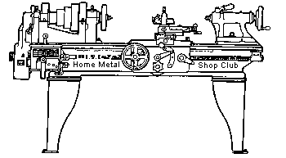  Volume 7, No 11 - November, 2002

President - | Tom Moore | Vice President - | Chuck West
Treasurer - | John Hoff | Secretary - | Joe Scott
Webmaster -  Founder - | Dick Kostelnicek  John Korman | Editors - | David Whittaker  Jan Rowland
 |  | SIG Coordinator - | Dennis Cranston
Statement of Purpose
Membership is open to all those interested in machining metal and tinkering with machines. The club provides a forum for the exchanging of ideas and information. This includes, to a large degree, education in the art of machine tools and practices. Our web site endeavors to bring into the public domain written information that the hobbyist can understand and use. This makes an organization such as this even more important.
Business Meeting
Minutes are sent via email or regular mail to club members.
Regular Meeting
- Collier Library. Houston, TX. October 12, 2002. 1:00 pm. There were 26 members plus visitor Vince D'Amico. Tom Moore, President, presiding.
- Members were polled to see who might need a PC projector for presentations. Only 2 said yes. We won't be purchasing a PC projector.
- Because of privacy and the amount of junk mail being sent, the club will not distribute an E-mail and addresses list. A sad commentary on our times! Exchange personal information at the meetings or call one of the club officers for contact information.
- A concrete slab was poured for mixing casting sand at Zube park.
- The swap meet will be scheduled soon, under the trees, and on a non-public day.
- The model train club has surplus metal to sell.
- Dennis Cranston was given an award for his service as Vice-President, President, and SIG coordinator. Dick Kostelnicek received an award for serving as Secretary and Webmaster.
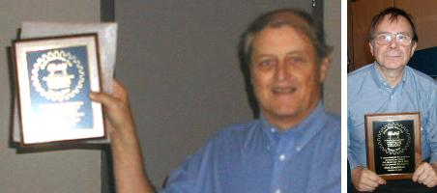
Dennis Cranston - Dick Kostelnicek

Show and Tell
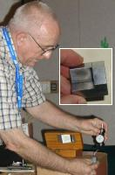  Joe Williams showed a corner finder, a B&S center finder and some 1-1/4-in. wide rubber belting he has available. | 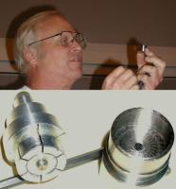  Ray Ethridge showed how he repaired a bandsaw wheel support by fabricating a spindle bushing from his own ZA12 casting. He also brought a homemade expanding mandrel to hold an odd-sized part.  . |  | 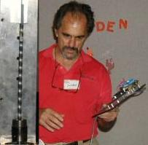  Bill Swan demonstrated the power of a stepper motor by twisting a piece of key stock. | 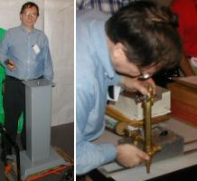  Dick Kostelnicek showed his weldment grinder stand that was smoothed with Bondo, sanded and painted. It looks like a fine casting. He demonstrated his home built flame cutting tractor and track, how to cut empty 1-gal. solvent cans to make storage drawers, and a lathe ball turning attachment.
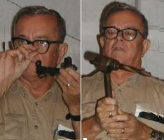  Joseph Scott brought an old centering device for face plate work and a holder for drilling in the lathe. He also showed a punch set for making a M1 rifle sight screw seal. |  | 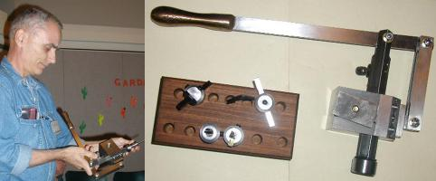  Ed Gladkowski showed his home built lever actuated shaper that mounts on a lathe in place of the toolpost. One use is cutting key ways in work held at the headstock.
Presentation

Our program consisted of two videos on TIG (Tungsten Inert Gas) welding that were provided by Chuck West, member HMSC. Chuck is taking welding classes at a local junior college. The videos explained which polarity to use on various metals.
The discussion concerned auto-darkening welding hoods. The consensus was that they work well with the costlier ones having faster light-to-dark transition times. A discussion on general welding experience and tips followed.
Metal Casting SIG
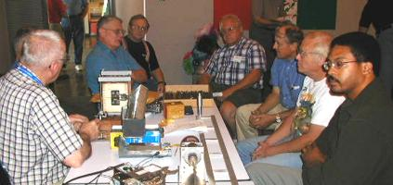
Tom Moore discussed the plans for a club foundry at Zube Park. It was decided that when we had a tailgate sale there, we would get together afterwards and work on a molding bench and other items. Ed Gladkowski showed the special flask he used to cast a handle for his lathe attachment. In this flask, he cast a hand-hold piece in silicon bronze directly on a metal bar (see Show & Tell). by Dennis Cranston
Computer Numerical Control SIG
No activity this Month.
Featured Articles
Lathe Spindle Outrigger Support by Dick Kostelnicek - HMSC Member
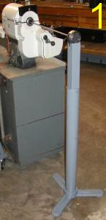
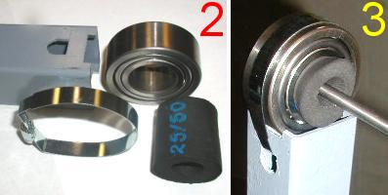
Turning an unsupported slender rod, that extends far beyond the backside of the spindle, represents a serious danger to both equipment and lathe operator. For a given diameter, length, and rod stiffness, there is a rotational speed above which the rod is unstable. As the unsupported end is thrown off-center, centrifugal force drives it further off-center. The result, a catastrophic whipping of the rod as it bends ninety degrees to the spindle slashing everything traverse to the lathe axis. Although I was always cautious of this possibility, recently, a 3/8-in. dia. 3-ft. long drill rod got away from me at about 400 RPM.. It did quite a bit of damage to a swing-out tool tray attached to the back of the head stock casting. I resolved to ensure that this not happen again.
Figure 1 shows my solution for supporting slender rods by using a spindle outrigger. It is built from a light weight, three legged, grinder pedestal (Harbor Freight #42986) supporting a telescoping length of 2 x 2-in. square tubing. Fortunately, the square tube fits closely within the pedestal pipe. Attached to the end of the square tube is a roller bearing with a 1-3/8-in. dia. bore, larger than the through-hole in my lathe's spindle.
Figure 2 shows a short length of black, low density, rubber tubing, commonly used as insulation over refrigeration lines, that serves as a compliant centralizer. The rubber tube is stuffed inside the bearing's bore and compresses enough to accommodate rods between 1/4 and 3/4 in. dia. Used without the rubber centralizer, the outrigger is built stout enough to also serve as a dead weight support for large diameter, long rods.
The parts for attaching the bearing to the end of the square tubing are shown in figure 2. Notches were filed in the square tube's end to seat the bearing. A cross drilled 5/8 in. dia. hole had its top-side filed flat to accommodate a band clamp that ties the bearing to the tube as seen in figure 3.
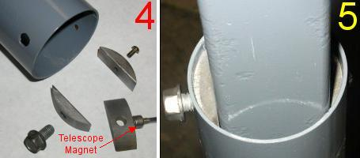
Figure 4 shows the parts that allow height adjustment and clamping of the pedestal's round pipe to the square extension tube. Two sets of new-moon shaped shims were cut from key stock and rounded on a belt sander. The left shim has a 3/8-16 threaded through-hole while the one on the right was tapped for a #10-32 screw. Figure 5 shows that the left shim provides sufficient thread engagement for the 3/8-in. bolt that couldn't be obtained within the thin wall of the pedestal pipe. The right shim is screwed down tight to the opposite side of the pipe. Tightening the 3/8-in. bolt cinches the square tube between the bolt's end and the opposed fixed shim.
A second set of shims is located halfway down the pedestal pipe. In the lower right corner of figure 4, a ceramic magnet, attached to a telescoping handle, is shown stuck to a shim. The telescope magnet was the prefect tool for locating the lower set of shims deep within the pedestal pipe.
External Spindle Support by J. R. (Joe) Williams - HMSC Member
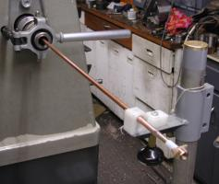
I suspect almost everyone has had a part bend when unsupported. Mine cost me a good work lamp on my old milling machine. The half inch stainless steel bar formed a nice 90-degree radius bend, and in a hurry, at 770-rpm, the speed I usually use. It sure gets your attention. My solution is shown in the photo. It is built around a section of cadmium plated 1-1/4-in. steel pipe attached to a couple of round heavy steel drops and has a vertically adjustable shelf at the top. The heavy round base makes it easy to roll around to get it out of my way when not in use. The work is usually supported thru a drilled hole in a piece of high density polyethylene or simply a piece of wood. The work in the photo is a section of heavy wall 3/8- in. copper tube with a special fitting on the end.
Welding Table by J. R. (Joe) Williams - HMSC Member
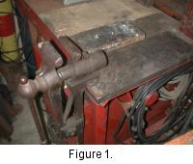
The welding table in figure 1 is constructed from sheet metal angles that are riveted together, a good exercise in riveting. The top surface is made from six 12 x 12 x 2-in. fire bricks set in a pan top with a heavy steel angle section on the right side and a section of steel angle set to form a V for positioning round parts. The old Post Vise (antique blacksmith's vise) was added later. The table is about 39-in. tall and built to provide space underneath for my welding machine. On the right side are two projections for storage of a short welding lead and ground cable. All the metal surfaces including the vise and the bench top are bonded together with welding cable to provide a ground for the work.
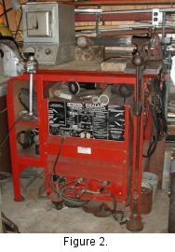
The welding machine sits on a caster base, figure 2, and is fabricated from welded 1/4 x 4-in. flat steel. This allows the machine to be close to the floor and rolled around. Otherwise, a fork truck would be required.
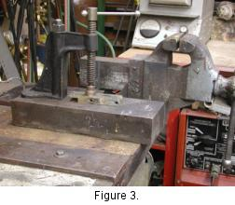
Figure 3 shows another welding station with a large steel bench block that has a screw clamp bolted to the top. The block is loose and can be moved around and fastened with additional C-clamps to the front ledge of the work bench. The clamp body came from a scrap pile minus the Acme screw and pad. The block has a ground wire attached at the rear to a common ground system that eliminates the problem of attaching a ground lead for stick or TIG welding.
My gas welding equipment, cylinders, including Argon, and hose are not shown. They sit to the left of the welding bench. A small heat treating oven, figure 3, is parked on the left side of the welding bench.
Another Welding Table by Dick Kostelnicek – HMSC Member
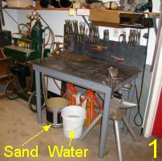
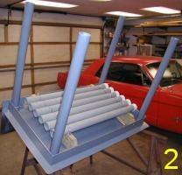
Figure 1. shows my welding table. It is constructed from 3/16-in. welded mild steel plate and 2-in. dia. pipe legs. It has an 18-in. high metal back-splash that is lag bolted into the wall studs. Hence, the table does not move when leaned or pushed upon. The legs screw into straight threaded pipe couplings welded to the table. The working surface is leveled by adjusting the amount of each leg's thread engagement. The backsplash and top are bare metal, while the underside and legs are painted. The top overhangs by 2-in. all around, figure 2, so that C-clamps or vice-grips can be used to secure work to the table top. I store my vice-grips and C-clamps by clamping them around the edge of the backsplash for easy availability.
Note the sand and water buckets under the table. I use sand as an amorphous fire brick. When poured in a pile on the table, it positions and supports odd shaped work pieces, prevents splatter from sticking to the table, covers hot welds so they cool slowly, and smothers the occasional fire. Water is used for quenching hot metal and to put out fires. Gas cylinders and hoses are located to the left of the table. Flux, rod, and solder are stored in the two pull-out drawers immediately above the table. Hoods, groves, and various welding jigs and fixtures are stored on three 12-in. deep open shelves attached to the wall above the pull-out drawers
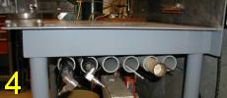
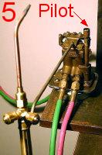
After construction and painting, several 2-in x 32-in. long. PVC tubes were suspended under the table, figure 2. These tubes hold a variety of gas welding and brazing rods. As shown in figure 4, the left most tubes are a convenient place to hold my pneumatic needle descaler and chipper chisel.
Figure 5 shows a gas-saver shut off device that is used to turn the torch on and off. When the weight of the torch pulls down on the hanger arm, the gas shuts off. When welding gases are present, the device has an acetylene pilot that burns continuously. By simply picking up the torch and passing it over the pilot, the torch ignites. The advantage is that the torch may be put down, shut off, and then re-ignited without ever adjusting the torch valves. The gas-saver is attached to a large ceramic magnet so that it can be stuck to any available metal surface.
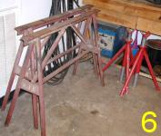
On the other side of the shop, as seen in figure 6, are the welding machine and various work supports. 35-ft. of welding cable is shown hanging behind the two metal support horses. I weld large items in the center of the shop, where there is a ceiling hoist, or out-of-doors. The long cables are quite necessary. When I use the table for electric welding, I run the cables across 15-ft. of shop floor and clip the ground cable to the edge of the welding table
Table Dimensions (inches)
Top  Height  Backsplash  Apron  Overhang | 45 x 27  33  10  3-1/2  2

The next meeting will be held on Saturday November 9, 2002 at the Collier Library 6200 Pinemont, Houston, TX at 1:00 p.m. Bring along a work in progress to show.  Visit Our Web Site  homemetalshopclub.org | 