 | 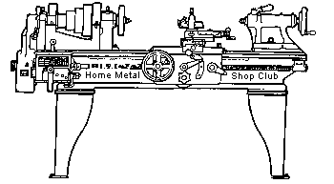  Volume 7, No 10 - October, 2002

President - | Tom Moore | Vice President - | Chuck West
Treasurer - | John Hoff | Secretary - | Joe Scott
Webmaster -  Founder - | Dick Kostelnicek  John Korman | Editors - | David Whittaker  Jan Rowland
 |  | SIG Coordinator - | Dennis Cranston
Membership Information
Membership is open to all those interested in machining metal and tinkering with machines. The purpose of the club is to provide a forum for the exchanging of ideas and information. This includes, to a large degree, education in the art of machine tools and practices. There is a severe shortage of written information that a beginning hobbyist can understand and use. This makes an organization such as this even more important.
Business Meeting
Minutes are sent via email or regular mail to club members.
Regular Meeting
- Collier Library. Houston, TX. September 14, 2002. 1:00 pm. There were 33 attendees including visitors Ken Scales and Art Behrings.
- Tom Moore, President, presiding. Tom spoke about arranging the swap meet at the Zube county park.
- REMINDER: Pay Your 2003 Dues; $12.
Presentations
High-Speed Machining
by Tom Whittenbach - TW Tool, Inc.
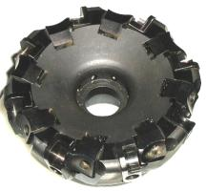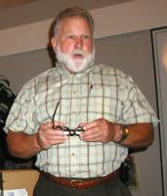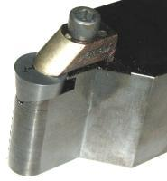
Tom narrated his personal videos demonstrating high-speed machining with reinforced ceramic inserts. One video showed a 12 in. dia. ball valve insert, turning at 9000 rpm, being completely machined on the outer surface in one pass. The ceramic insert actually melts the metal and spits it off so fast that the machined ball didn't even get hot. Neither coolants nor lubricants are used in this process. The surface finish was better than can be obtained with conventionally turning followed by grinding. The ceramic inserts are reinforced with carbon fibers derived from rice hulls. They cost about $25 each and require a very high surface speed to justify their use.
This is truly a look into the future of metal removal. An interesting hint discussed was to bevel the impact edge of an interrupted cut in order to reduce insert breakage. This technique should work with conventional carbide tooling. High-speed machining is the type of know-how which will keep us competitive in world markets.
Tom can be reached at 713.832.3308; twtool@wt.net; or TW Tool, Inc., P. O. Box 40156, Houston, TX 77240

Making Your Own Bullets
by J. R. (Joe) Williams - HMSC Member
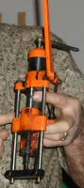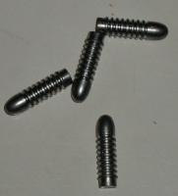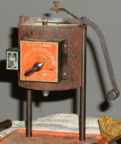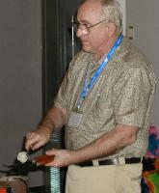
Joe showed how he casts bullets. He brought in a lead melting pot, bullet molds, and lead dipper. He demonstrated the steps in the casting proces, including fluxing the molten metal and dross removal from its surface. The various alloys for casting were discussed including the use of old wheel weights that include alloys which harden the bullets. The final steps shown were bullet sizing and lubrication. A good source for metal is from shooting range back stops. Making bullets by swaging from lead wire was covered as alternative to casting
Show and Tell
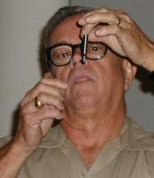  Joseph Scott showed an electronic edge finder which lights up on contact. "They're much easier to use than the mechanical types." He also showed a self-releasing tap head and a plastic drip bottle to direct lathe coolant. | 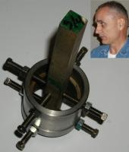  Ed Glaskowski showed his spider used to support irregular shaped objects in the center rest. For the gunsmith, this tool can center irregularly shaped gun barrels in a lathe. |   Whitney Rassback showed a Bosch electric hedge trimmer attachment for a European 220 V Bosch drill motor. Powerful stuff !
Metal Casting SIG
No activity this month.
Computer Numerical Control SIG

Dennis Cranston brought in a EMC controller program. This program, developed under government sponsorship, provides modern technology for small CNC controllers. It was designed to run under the Linux operating system. The installation shown at the meeting was a BDI or Brain Dead Install; not requiring previous Linux experience. The picture shows Gordon Lawson demonstrating some easy steps to customize the program installation. - by Dennis Cranston
Featured Articles

Horizontal Cut-Off Bandsaw Tips
by Dick Kostelnicek - HMSC Member
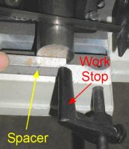
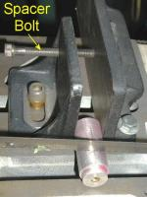
When I make repeat cuts, I use the saw's work stop to set how far the work extends beyond the blade. However, I also use a scrap of metal as a spacer between the end of the bar being cut and the saw's work stop. Then, I tighten the vise, remove the spacer, and complete the cut. The clearance, provided by the spacer, prevents the drop (piece cut off) from jamming between the blade and the work stop.
To cut a piece that is too short to be adequately held in the saw's vise, I run a 1/4-20 spacer bolt, that is threaded through the back of the movable jaw, up against the fixed jaw. That way I don't have to search for just the right thickness spacer to place in the other end of the vise.
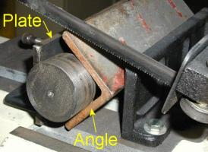
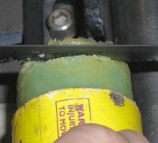
Sometimes the piece being cut is just a scrap that is too short to be held in the saw's vise. I extend the jaws by using a piece of angle and a flat plate that provide a three point contact gripping the short piece to be cut. The moveable jaw extension plate has a threaded bolt at its back end (not seen) that contacts the crotch in the angle so that the saw's jaws remain parallel when the vise is tightened.
My saw does not have a forced coolant-lubrication system. This creates a problem only when I cut soft aluminum, which tends to cold weld itself in the blade's gullets. The aluminum build up can be so great on a thick cut that the tooth's set provides insufficient kerf and the blade begins to drift to one side or the other. In order too prevent aluminum buildup, I touch a bandsaw wax stick periodically to the blade's teeth. In fact, I prefer to cut right through the stick's paper tube to a depth of 3/4 of the blade width to apply wax to the teeth and wipe clean the sides of the blade.

Personalizing a Bandsaw
by J. R. (Joe) Williams - HMSC Member
Modifications to my 7x12 in. Jet horizontal  cut-off bandsaw:  - A platform, using the wheels that came with the saw, to raise it by a foot; making it easier for a person of my height to use.  - Moved the lower frame side panel from the left side of the support frame so the coolant tank can be viewed from the drop side.  - A removable support rack, mounted under the saw base casting on the stock side, with a coolant return (photo 2) using 2 and 1 in. square tubing.  - A cord cap and receptacle in the electrical connection to the coolant pump.  - A clear Plexiglas window in the coolant tank to observe the fluid level (photo 1).  - Extended the cut in the return wheel casting so I could use slightly shorter blades - the result of blade repair.  - A larger table used when the blade is in the vertical position. | 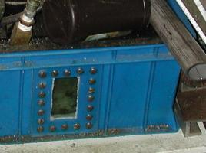  1. Coolant Tank  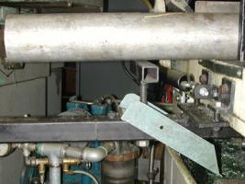  2. Stock Support

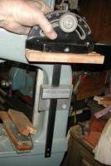  3. Miter Holde | Modifications to my Delta 15 in. vertical bandsaw:  - Revised blade tensioning mechanism to include a crank handle.  - A storage holder for the miter cut-off slide assembly (photo 3) with a larger angle setting knob.  - A storage hanger for the rip fence (photo 4).  - A cart with wheels making it easy to move the unit around,  - A table top protector - made from laminated material with underside stand-offs - held in place when the blade guide is dropped providing additional work space.  - A work light.  - Revised motor support to pivot the motor to make belt changing easy as the original Delta support was an after thought of theirs.  - A clear Plexiglas window in the rear belt guard (photo 4) - so I can observe which pulley is being used and if the low speed gear is engaged.  - Screws with plastic knobs (photo 4) to allow entry to the motor area without a screw driver.  - A long roll pin in the table taper pin to allow its removal by hand rather than with a wrench (photo 5).
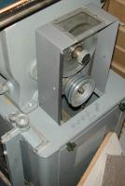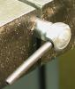
4. Guard Window, Fence 5. Table Pin
Holder, Door Knobs

Square Drive Crank from a Weldment
by Dick Kostelnicek - HMSC Member
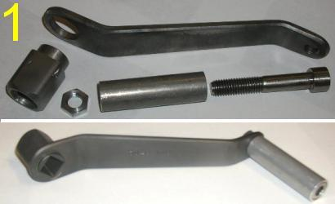
I fabricated a 5/8 in. square drive crank from a machined weldment (welded up from pieces). Figure 1 shows the crank's parts and finished assembly. The square socket head was built-up from four flats welded together and then machined on the outer surface. The finished head was silver brazed into a 1 in. dia. hole drilled in the big end of a bent arm. A rotating sleeve hand grip was attached via a threaded hole in the small end of the arm using a 3/4 in. socket head cap screw and jamb nut. The entire 8 in. long crank was Parkerized ® - a hot dip chemical coating that prevents rusting.
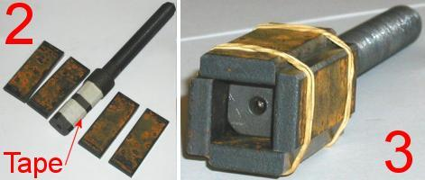
Figure 2 shows that the socket weldment consisted of four segments cut from a 2 x 1/4 in. mild steel flat. The 3/4 in. wide segments were temporarily secured around a mandrel with rubber bands, as shown in figure 3. The mandrel was one of the square headed bolt shanks that will be eventually driven by the crank. Two layers of masking tape was wrapped around the mandrel in order to provide 0.008 in.clearance for a sliding fit between the finished square socket and the driven shanks.
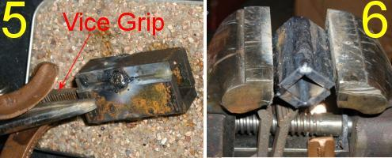
Small dabs of quick setting epoxy resin were used to tack the socket shells together in preparation for welding. Figure 4 shows the mandrel being slowly turned in a lathe while the epoxy cured. Rotating the weldment prevents the resin from sagging or spreading along the shell's seams. Figure 5 shows the shells being tack welded between the epoxy tacks. I tack weld such small pieces in a sardine can filled with sand. The sand provides support for the odd shaped weldment and prevents splatter from sticking to the surface of the metal welding table. A long nose VISE-GRIP ® was used as an narrow extension clip for the large bronze ground clamp. The weldment was cooled in water after each edge was tack welded in order to prevent heat from softening of the epoxy positioning tacks.
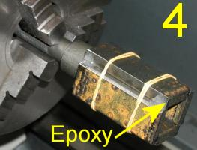
After tack wedling all four edges, the epoxy was removed and the seams were finished welded. Figure 6 shows the use of an old vise, that has been bolted to the metal welding table, to position small parts. All paint was stripped from the vise, thereby, providing a good electrical ground connection to small parts being held for welding
Figure 7 illustrates how I rounded over the corner weld beads using a disk sander. Finally, figure 8 shows the square socket after being sandblasted inside and finished turned on the outside.
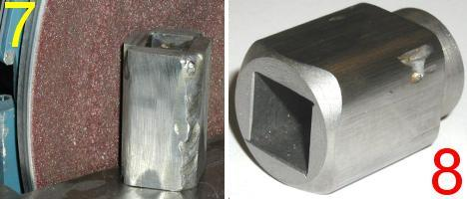
Now, I know that I could have purchased a torquing socket for 5/8 in. square headed bolts, and then turned it to produce an equally good part for the crank. But, sockets for square head bolts are not available at my local home improvement center. Besides, this is what I do for entertainment Sunday evening. Lastly, I'm sure I'll be hearing from the shaper buffs, about the merits of their machines in making square holes.

The next meeting will be held on Saturday October 12, 2002 at the Collier Library 6200 Pinemont, Houston, TX at 1:00 p.m. Bring along a work in progress to show.  Visit Our Web Site  homemetalshopclub.org | 