 | 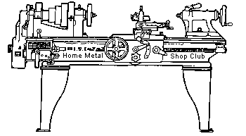  Volume 8, No 10 - October 2003

President - | Tom Moore | Vice President - | Chuck West
Treasurer - | John Hoff | Secretary - | Jim Appleby
Webmaster -  Librarian - | Dick Kostelnicek  Dennis Cranston | Editors - | Jan Rowland  Dick Kostelnicek
Founder - | John Korman | SIG Coordinators - | Dennis Cranston  Richard Pichler
Statement of Purpose
Membership is open to all those interested in machining metal and tinkering with machines. The club provides a forum for the exchanging of ideas and information. This includes, to a large degree, education in the art of machine tools and practices. Our web site endeavors to bring into the public domain written information that the hobbyist can understand and use. This makes an organization such as this even more important.
Business Meeting
Minutes are sent via email or regular mail to club members.
Regular Meeting
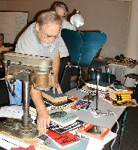
Collier Library, Houston Texas, 1:00 p.m., September 13, 2003.
The great book give-away was a success. Mark Kilgore was glad to see that all his books were taken, with some people getting books that they had been searching for. He did, however, lose one book that was marked for sale, The Colt Double Action Revolvers, A Shop Manual, Vol. I, priced at $22. Please return or pay for it.

The Sept. meeting featured the various kinds of lathe radius attachments used by club members. For the October meeting we will be having a FLY CUTTER ROUND-UP. So, bring them to the meeting, preferably with pictures of their use.
Member News

John Korman, the founder of our club, died September 19, 2003. A article, Houston Home Metal Shop Club Origins, written by Keith Mitchell, appeared in the September, 2002 club newsletter. It describes how John brought together metal workers and tinkerers in the Houston, TX area in 1996. John is also the author of many HMSC newsletter articles.
You know, the older we get the more we know, and understand the vile work of the dark specter. John's good work will live on, in his children, and his dreams. Each time we meet, we celebrate ideas and the love of the craft that John knew so well. What John helped create is a living thing, and the unmeasured success of what we now enjoy is tribute to John's vision and dedication. As a former President of the club, I interacted with John on many occasions, and can surely say that John had a passion for the club and it's success. We will miss him, but once a month, on the second Saturday, we will talk the talk he loved to hear, recount the experiences he too lived, and relish the gift he left us. - Vance Burns
Presentation
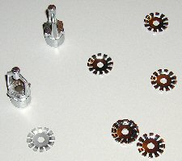 | J. Kelly Mowry, President of Gull Industries, spoke about production metal plating processes including, precision dense chrome, electroless nickel, high production nickel, vapor honing, and ion beam coatings. | 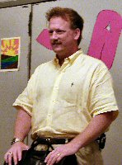
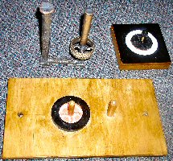
Metal Casting SIG
Ed Gladkowski brought the silicon bronze casting, drag plate and core pattern for a pulley for a model steam engine he is building.
Editor Note: Oops! This picture was left out of the September newsletter.

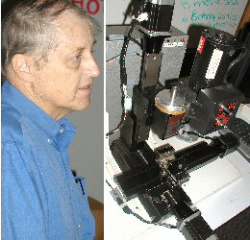
Computer Numerical Control SIG
The CNC SIG looked at Dennis Cranston's Sherline CNC Machining Center. The unit is based on a CNC ready Sherline and 187 oz-in steppers and a Xylotex driver. It used a Mini-ITX PC Mother board running XP Pro. The control program is currently MACH1. - Dennis Cranston

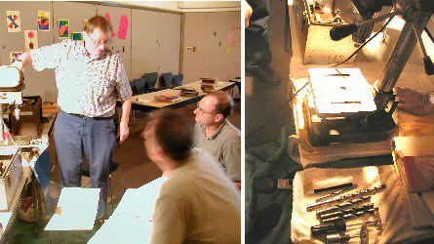
Novice Sig
The Novice Sig worked on hole drilling. They brought a desktop drill press and practiced drilling holes in the metal plates that they scribed and center punched during the Sept. meeting. Some of the drill types that they discussed were: Silver & Demming (reduced shank), Center Drills, Counter Sinks, Spur Point (sheet metal drills).

Show and Tell
  Jim Appleby showed some small brass candlestick holders that he fashioned. | 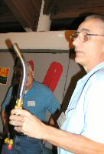  Ed Glaskowski brought his large air-propane torch. It sucked all the oxygen from his shop in just a minute. | 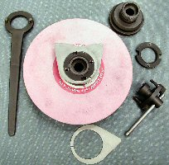  Dick Kostelnicek showed the equipment that he built to mount and statically balance 7-in. surface grinder wheels.

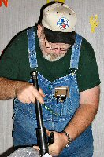  Doug Chartier showed some large Aloris tool holders and a collet stop with an expanding cam that grips the inner wall of the spindle's through hole. | 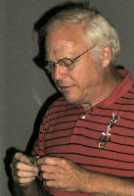  Ray Ethridge showed a rifle sight made by Joe Scott that was brazed in Ray's hydrogen atmosphere furnace. | 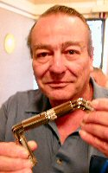  Art Volz brought one of the toys we all played with as children. It's a U-joint made from bent rods.
Featured Articles
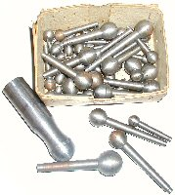Some turned ball ends by Tom Moore and Ed Gladkowski | Roundup of Lathe Radius Turing Attachments  edited by Dick Kostelnicek - HMSC member  Several members brought their radius turning attachments for turning balls on a lathe. | 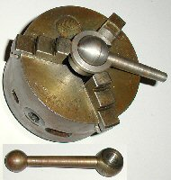  Tom Moors' split ring clamp for holding a ball for offset boring.

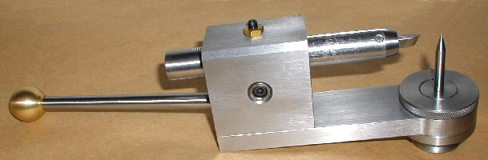
Ed Gladkowski's radius attachment replaces the compound and swings in the horizontal plane about the compound post. The vertical scriber is aligned by the cross slide with a dead center placed in the tailstock The height of the top of the 1/4-in. tool bit is permanently set on the lathe's center. In order to turn a ball, just start from the tailstock end and manually rotate the entire attachment by its handle. The ball radius is determined by moving the shank holding the bit in or out of the device.

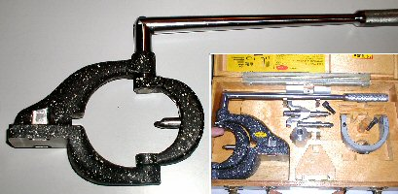  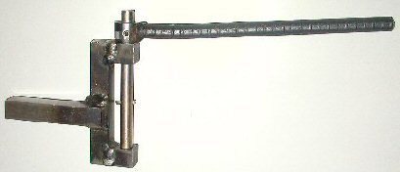 | Joe Williams brought in his factory-made and home-made versions of the traditional radius attachment. The bit rotates in the horizontal plane. The upper tool shown is set up to cut a ball. By reversing the bit in the swinging U-shaped arm, it also can cut an inside radius (dish). The home-made weldment tool, shown in the lower photo, cuts an inside curve.

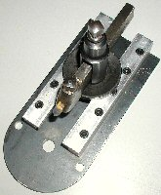
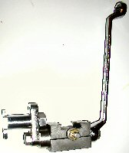
At the left is Dick Kostelnicek's radius attachment that turns large balls, mainly used in crowning pulleys. It replaces the compound and swings about the vertical axis or compound post. It uses a classic post style tool holder. It is a bit of trouble to set the bit on the lathe center and get the swing center beneath the ball to be turned. Dicks lathe has a DRO on both axis, so the coordinates for centering the radius attachment can be saved and reused the next time the attachment is installed on the lathe.
The right photo shows a ball turning attachment that rotates about the horizontal axis that is perpendicular to the lathe's axis. The bit rotates about a 1-in. shank that is supported by a horizontal 1-in. Aloris style boring bar holder. Once the height of the shank's center is set to that of the lathe's axis, the attachment can be removed and subsequently reattached to the toolpost and remains on center. The ball radius is determined by adjusting the offset slide attached to the shank. A box wrench is used to turn the tool around the ball being cut.

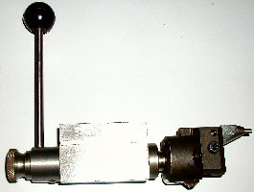
Tom Moore's attachment rotates about the horizontal axis tthat is perpendicular to the lathe's axis. It attaches directly to the T-slots in his Myford lathe's cross slide. The ball radius is set by moving the bit holder's cross slide that is attached to the rotating shank. Similar devices use a boring head to produce the offset in order to change the ball radius.
Remember to bring your FLY CUTTERs to the next meeting's tool roundup!
Radius Grinding Fixture
J. R. Williams - HMSC member
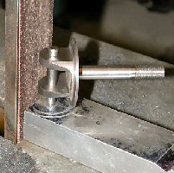
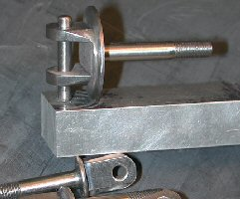
The project was to machine a quantity of special hinge bolts, for a WWI replica airplane, with a uniform 1/4 inch radius on the ends of the bolts. The first idea was to hand grind the radius to a scribed line, but I soon gave up on that idea and went for the fixture in the photo. I used a base of 3/4 inch aluminum bar stock and drilled a hole thru and reamed a little over half way for a 3/16 diameter dowel pin that was pressed in place. To grind the radius, I used my 1 inch wide belt sander. The part on the fixture was pressed up against the belt and the part was rotated while holding the fixture steady. The result was a uniform radius on the parts. The radius part of the project was the easy part of the project. The large part, with the two sections, was made from a 1-1/4 inch diameter bar stock of 4130 steel with the threaded section 1/4 inch in diameter. Fabricating a fixture to machine a radius does not have to be complicated.

A Sea Story
by an anonymous HMSC member
A few wars ago in 1968, my old destroyer was back in the south China sea off Vietnam after some quick repairs in the Subic Bay (Philippines) shipyard, when a little problem came up. The steam turbine-driven main condenser water circulating pump in the forward engine room wasn’t working too good (to put it mildly). The pump end had a water-lubricated split bronze sleeve bearing about 14 inches long, 3 inches ID by 4 inches OD . The 1/2-inch thick bearing walls were perforated with a bunch of 3/8-inch holes for water to cool and lube the shaft. The two halves of the split bearing were aligned by four dowel pins in the mating faces.
Maybe because things were kind of busy then, the shipyard workers had reassembled the bearing with only two dowels engaged, so that each half of the sleeve overhung the other by about three inches on each end. Somehow, they managed to get it back in the pump bearing housing which was also split, put the cover on, and slug up the nuts.
When the pump finally quit, it was torn apart and the mangled bearing found. When it had been bolted up, about 3 inches of each half had been bent diagonally outward by almost an inch. Since we had no spare bearings on board, it was fix it or leave our duty station and limp back to the yard.
Fletcher-class destroyers had a 16 inch lathe, a drill press, and a small workbench with a good heavy bench vise. The way we fixed the bearing was as follows:
The pump shaft was “miked” and a piece of brass bar stock turned between centers .004 inches oversize for running clearance, using the old rule of thumb “.001 inch of clearance per inch of shaft diameter plus .001 for luck.
Each bearing half was held in soft jaws in the bench vise and beat back into something like the original shape using the biggest (about 5 pound) rawhide mallet we had in the ship. Sounds extreme, but there was nothing to lose; it was no good as it was.
The two bearing halves were then fitted to the .004 inch oversize bar using Prussian blue, half-round files and finally scrapers. When it was as good as we could get it on the bore, the outside diameter was fitted into the pump housing again using blue, files and scrapers, while hanging upside down in the bilge through a hole in the engine room deck plates.
Not much more to add – the pump was reassembled (this time with all four bearing dowel pins aligned!), lit off and put on the line. It ran fine until we got back to the U.S.A. about six months later.
Maybe the moral is, you don’t always need elaborate equipment to do a job if it really has to be done.

The next meeting will be held on Saturday October 11, 2003 at the Collier Library 6200 Pinemont, Houston, TX at 1:00 p.m. Bring along a work in progress to show.  Visit Our Web Site  homemetalshopclub.org | 